Bloomberg

Interest Rate Swap Trading

USD Interest Rate Swaps – SWPM <GO>
SWPM USD 10MM 5Y <GO>
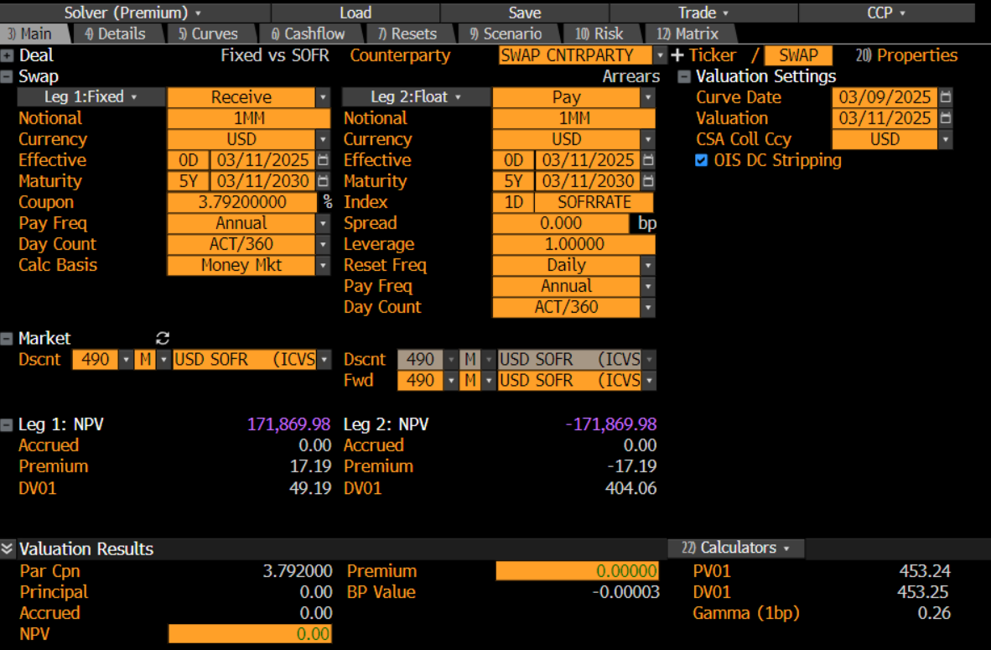

Fixed Cash Flows
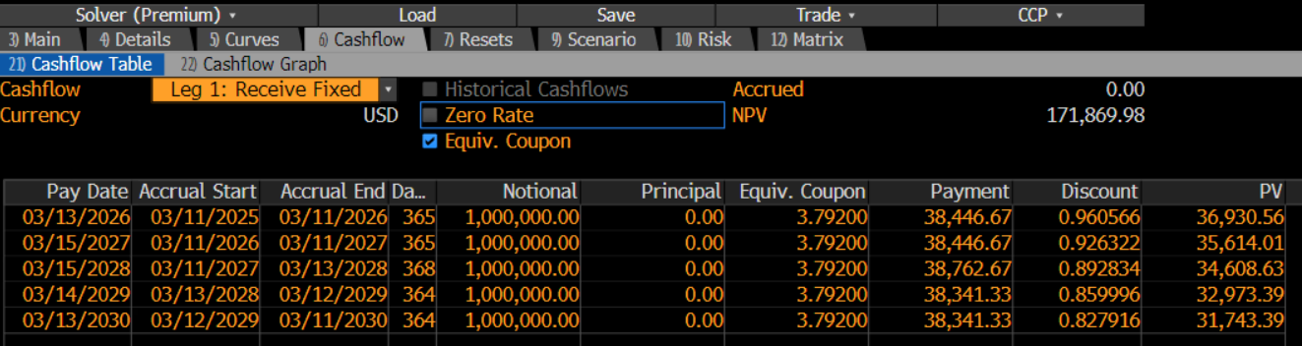

Float Cash Flows
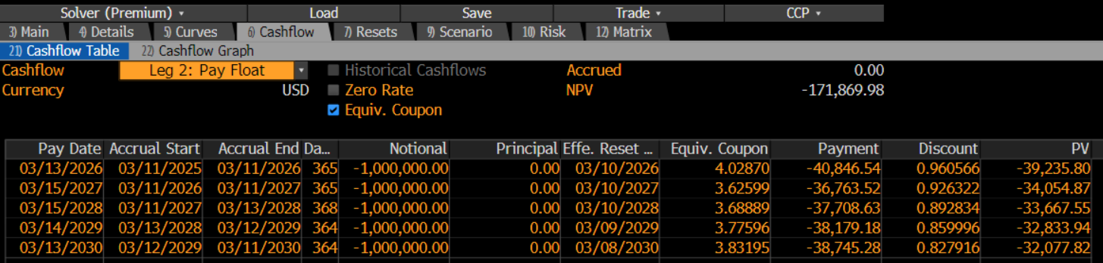
USD Swap Curves – ICVS <GO>
ICVS USD <GO>
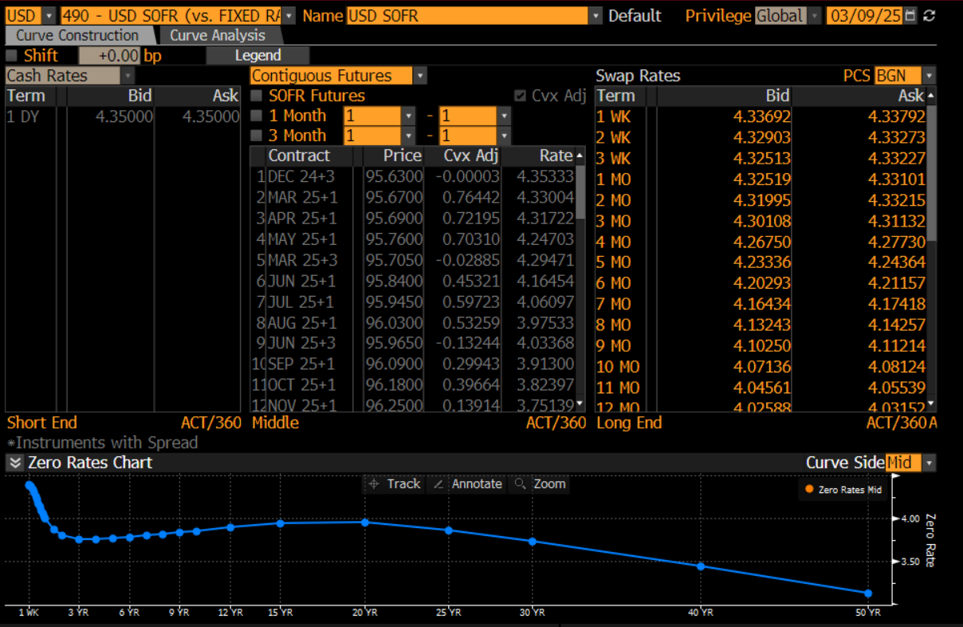

STIR Futures
1M or 3M Futures Contracts
Serial or Contiguous
- Serial 3M – Mar+3, Apr+3, May+3, Jun+3, etc. (Monthly Overlapping Futures Contracts)
- Contiguous 3M – Dec+3, Mar+3, Jun+3, etc. (Quarterly Non-Overlapping & Continuous)
Convexity Adjustments
Futures are marked-to-market with daily margin, this removes convexity (curvature). We must add this curvature back as swap curves are not marked-to-market and have no margin requirements.

Serial or Contiguous Futures
Serial Futures – Monthly Overlapping Contracts
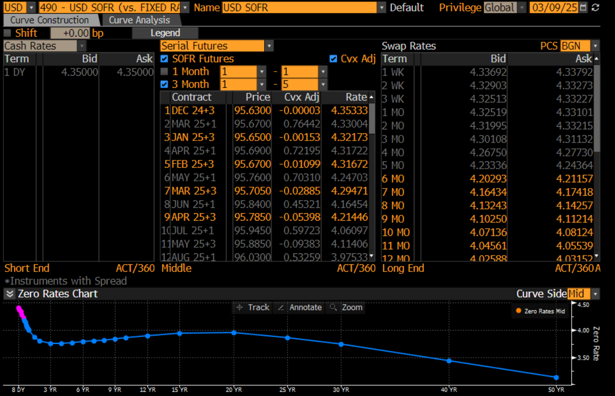

Contiguous Futures – Quarterly Continuous Contracts
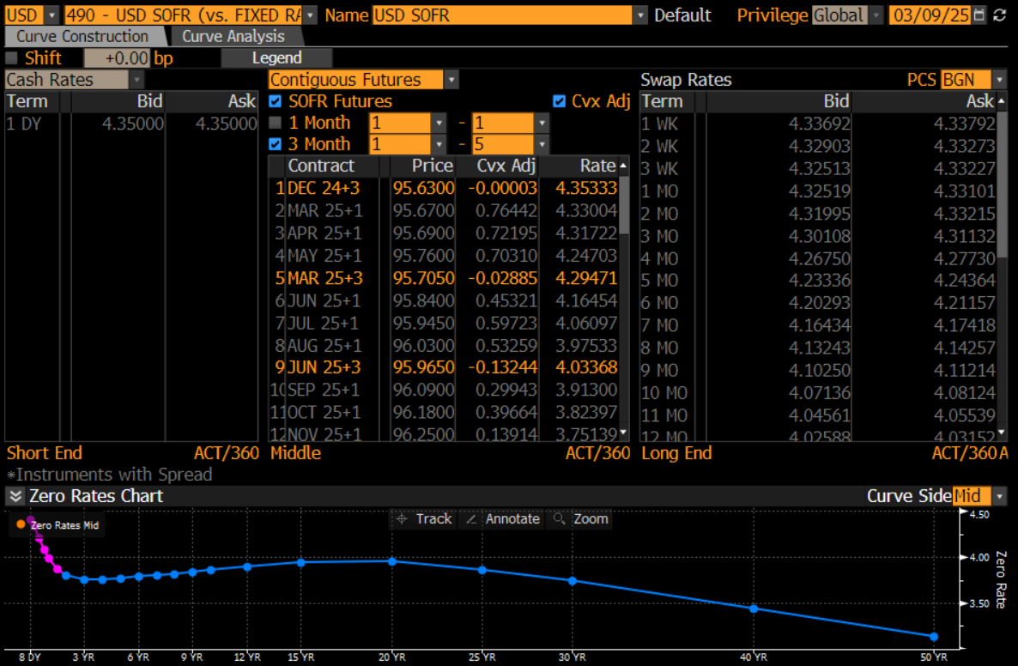
Interest Rate Benchmarks – IRSB <GO>
SOFR Swaps
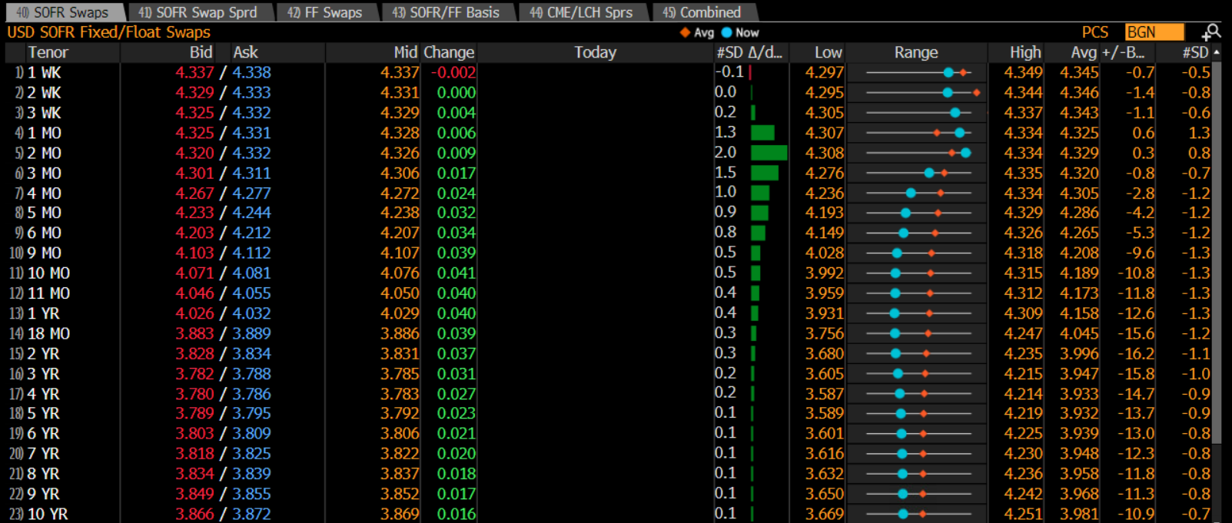
SOFR Swap Spreads - Spread over US Treasuries
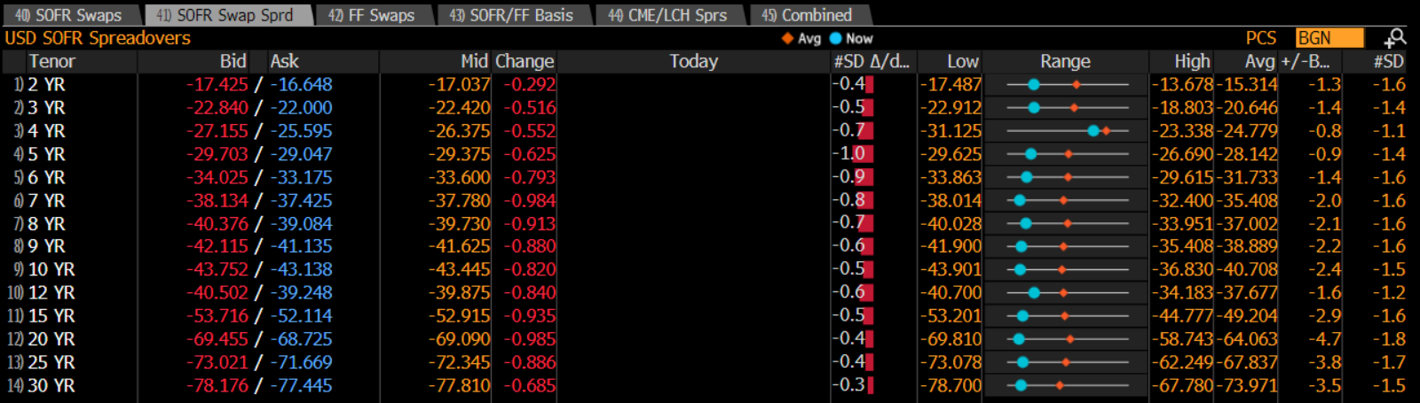
Combined
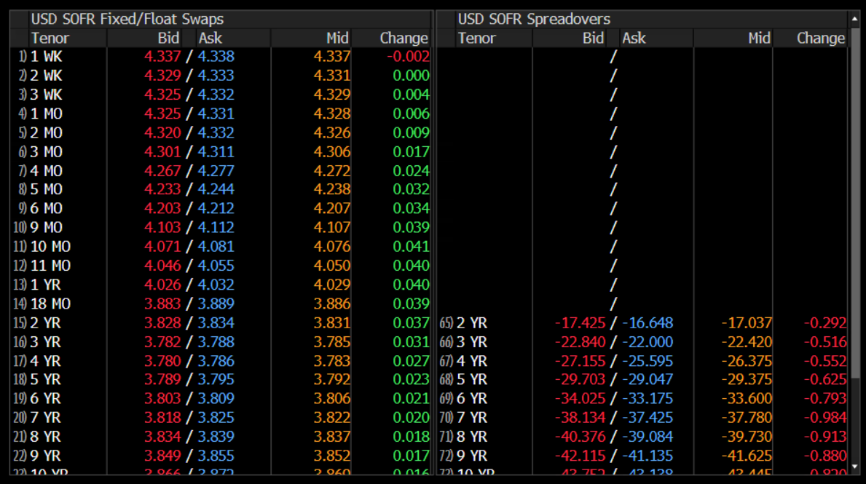
IRS Trading Portal – BBTI <GO>
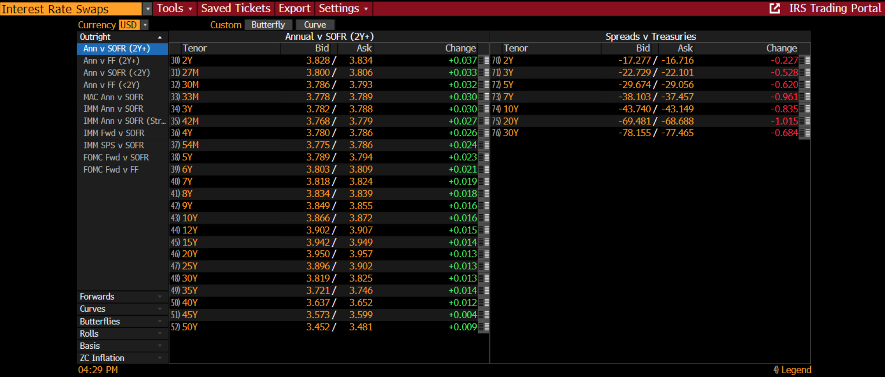

US Swap Market – USSW <GO>
